3 Complete the sentences. Use should or shouldn’t and the correct form of the verbs in brackets.
1 Joe feels sick. He _________ (eat) anything.
2. Alice is bored. She _______________ (do) something interesting.
3. Lilly’s wrist hurts. She ____________(play) tennis today.
4. Max is cold. He _________________ (put) on a warm jumper.
5. David is thirsty. He ____________(drink) some water.
6. He ___________(sleep) in the armchair. He ________________(go) to bed.
 | _____ | 7
4 Choose the correct words.
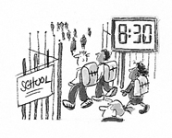 | 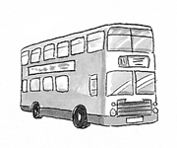
You must / mustn’t come in time. | 1 You must / mustn’t take the bus.
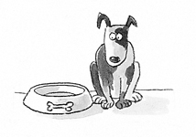 | 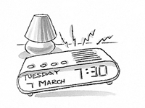
2 You must / mustn’t feed the dog. | 3 You must / mustn’t get up at 7:30.

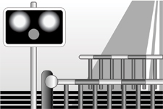
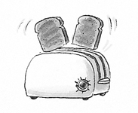
4 You must / mustn’t burn the toasts. | 5 You must / mustn’t go.
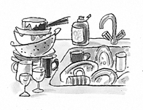
6 You must / mustn’t forget to wash up.

 | _____ | 7
5 Write the words under the correct heading.
be rude to people greet your teachers
go to school tidy your room twice a day
park your car on grass
shout in classes
eat lots of chocolate
go to hospital if you have a bruise

must | mustn’t | don’t have to
 | be rude to people

 | _____ | 7
6 Complete the words.
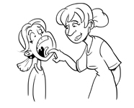 | 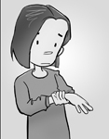
1. She’s got a s _ _ _  t _ _ _ _ _. | 6 Her w _ _ _ _ h _ _ _ _.
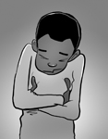 | 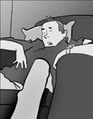
2 He f _ _ _ _  c _ _ _. | 3 He f _ _ _ _  t _ _ _ _.
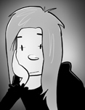 | 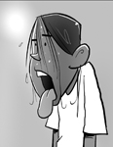
4 She is b _ _ _ _. | 5 I am t _ _ _ _ _ _.

 | _____ | 6
7. Complete the text with the correct form of these phrasal verbs.
look at - get off - sit down - try out - get up - put on - try on - get on
I had a great day last Saturday. I (1) ________ really early and I took the number 11 bus into town. I (2) ________ at the train station where I met my friend Darren. We (3) ________ the 9.15 train to London. We wanted to go shopping in Oxford Street because there are lots of great shops there. I (4) ________ lots of sweatshirts. I bought a blue one with Yankee Stadium on the back. Darren bought a new camera. I (5) ________ my new sweatshirt because I wanted to wear it to the Hard Rock Café. That’s where we had lunch. It was amazing. We (6) ________ at a table near an old jukebox. It was awesome! And we (7) ________ all the great guitars and albums on the wall. Darren (8) _________ his new camera and took lots of great photos. It was a brilliant day.

 | _____ | 8
8 Choose the correct words.
1. Where did you get at / off / up the train?
2. Hi! Come in and sit down / for / off.
3. I’m going to take on / off / out the chicken from the oven.
4. Look up / for / at the dog playing with the football.
5. I’m hot. I’m going to take off / on / up my sweatshirt.
6. The phone’s ringing. Can you pick it on / up / out?
7. Can you switch out / on / at the TV? Dad wants to watch the sport.
8. I’ll help you look for / at / out your keys. Maybe they’re in your room?
 | _____ | 8
4. Complete the sentences. Choose from these words.
have - should - headache - matter - sick - feel - shouldn’t - painkillers

Tom Mum, I don’t (1) __________ well.
Mum What’s the (2) ____________________?
Tom I feel (3) __________ and I’ve got a (4) __________.
Mum Well, you (5) __________ eat anything. I think you (6) __________ drink some water.
Tom Have we got any (7) __________?
Mum Yes, we (8) __________. Here, take two.
Tom Thanks, Mum.

Správné řešení:
3.
- shouldn’t eat
- should do
- shouldn’t play
- should put
- should drink
- shouldn’t sleep, should go
4.
- must
- must
- must
- must
- mustn’t
- mustn’t
- mustn’t
5.
must | mustn’t | don’t have to
greet our teachers  must go to school | be rude to people  park your car on grass  shout in classes  eat lots of chocolate | tidy your room twice a day  go to hospital if you have a bruise
6.
- sore throat
- feels cold
- feels tired
- bored
- thirsty
- wrist hurts
7.
- got up
- got off
- got on
- tried on
- put on
- sat down
- looked at
- tried out
8.
- off
- down
- out
- at
- off
- up
- on
- for
9.
- feel
- matter
- sick
- headache
- shouldn’t
- should
- painkillers
- have

