3 Put the words in the correct order to make sentences and questions.
1 is / on / my friend / the t-shirt / putting
__________________________________
2 pizza / dinner / we / having / for / are?
__________________________________
3 on /listening /her mobile / to / she /is / music
__________________________________
4 playing / a ball / the dolphin / with / is?
__________________________________
5 are / school / your friends / to / going
__________________________________
 | _____ | 5
4 Match the beginnings of the sentences 1–5 with the endings A–F.
Mum is  1 He always  2 The woman feeds  3 Do cows eat  4 I am waiting  5 What are you | A elephants every day.  B grass?  C doing at the moment?  D cooking dinner now.  E does his homework in the evening.  F for my friends now.

 | _____ | 5
5 Correct the mistakes in the sentences.
You must to tidy your room.
You must tidy your room._______________
1 They must doing their homework.
___________________________________
2 He must feeds the dog.
___________________________________
3 I must to go shopping this afternoon.
___________________________________
4 We do must get on the coach.
___________________________________
5 You must going to school every day.
__________________________________
 | _____ | 5
7 Choose the odd word out.
1 zebra lion dolphin camel
2 frog eagle carp crocodile
3 monkey dolphin rabbit tiger
4 eagle camel parrot penguin
5 foal kitten zebra calf
 | _____ | 5
6 Match words with pictures.
1 calf 5 foal
2 piglet 6 whale
3 rooster 7 rabbit
4 sheep 8 hedgehog
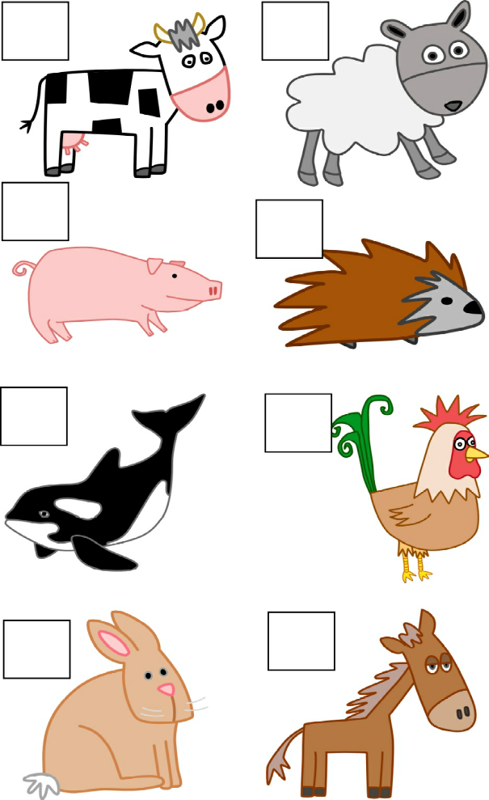
 | _____ | 8
8 Complete the dialogues. Use object pronouns.
A Do you like tennis?
B Yes, I do. I play it every week.
1 A Who’s that boy?
B That’s Jack. I play tennis with
___________ every week.
2 A Do you know Maria?
B Yes, I do. She sits next to ___________.
3 A Do you like pizza?
B No, I don’t like ___________ .
4 A Do you know Jessica, the new girl at our school?
B No, I don’t. But my friend knows
___________.
5 A Are you and your brother in this photo?
B Yes, we are. You can see ___________
here.
 | _____ | 5

